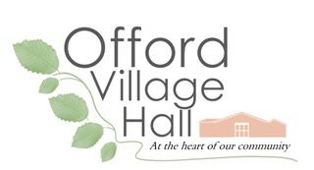

OFFORD VILLAGE HALL 300+ CLUB
(OFFORD RECREATION HUT)

Registered charity no. 302653

The 300+ club provides funds for the maintenance of YOUR Village Hall as well as cash prizes for lucky winners! The club needs between 200 and 400 members (over the age of 16) to run efficiently.

Each member has a unique share number(s) at a subscription of 50p per month, payable as £6 per year. Approximately half the membership subscription is allocated to monthly prize draws. In recent years we have had over fifty lucky winners and have given almost £1000 out as prizes and the same amount has benefited the Village Hall.

Draws will take place at village clubs or events each calendar month, beginning in March and winners will be notified.

To join please fill in the application form and contact:
Mrs Helen Bosworth, 127 High Street, Offord Cluny. Tel: 811892
Or Mrs Jenny Murby, 2 The Haycroft, Offord Darcy Tel:811474
………………………………………………………………
MEMBERSHIP APPLICATION FORM: 300+ CLUB

Name Tel Number

E mail Mob Number

Address

Number of shares

I enclose the sum of £6 per share TOTAL £

Payment preferred by bank transfer to: Offord Recreation Hut
sort code: 207481
Account No: 10676160 (Barclays Bank)
Or by cheque payable to Offord Village Hall or by cash.
Please tick here to indicate that you are content for your name to be published (normally on our website and in Out & About) should you be a winner in the monthly prize draws.
Please tick here to indicate that you are content for your details to be held and processed for the purpose of keeping in touch with you and for administering the club.

